NeighborhoodLIFT Program Map – El Paso, Texas
El Paso County Eligible LIFT Geography
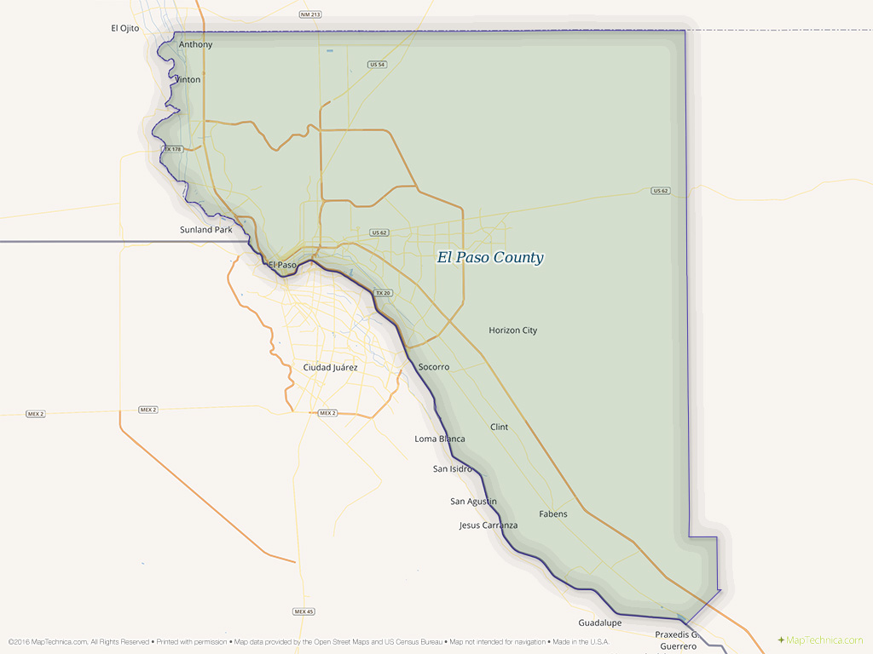
1. Navigate to the El Paso County Central Appraisal District ‘Property Search’ web page via the following link: http://www.epcad.org/Search
2. Enter the street number and street name of the property in the “Search by Name, Address, PropertyId, or GeoID” search field at the top of the page. (Omit street direction such as N, S, E, W and street type such as ST., RD., AVE. etc.). (The “Year” field will default with the most recent year’s pending or actual assessment information.)
3. Click the “Search” button. If the property address is located in the El Paso County database, one or more “Found” results will display below the search field. If more than one property displays, scroll down the list and confirm the correct property is on the list. The property IS eligible for NeighborhoodLIFT financing.
(NOTE: Clicking the “Details” link to the right under “Appraised Value” will open a detailed property results web page. It includes comprehensive “Property”, “Values” and “Taxing Jurisdiction” data along with improvement information and historical taxing and ownership data etc.)
4. If the property address is not found in the Travis County database, the web page will return zero “Found” results and the message: “No more results for "XXXXXXX” below the results line. The property IS NOT eligible for NeighborhoodLIFT financing.

